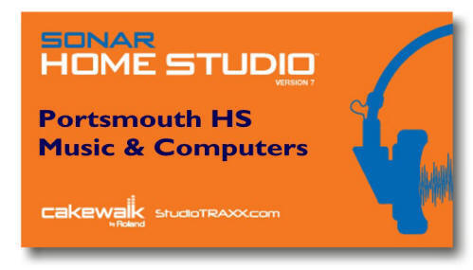
Name:______________________________
MIDI
STUDY GUIDE for Cakewalk Sonar

1. What does MIDI stand for?
2. Why was MIDI invented?
3. What is General MIDI?
4. What are Tracks?
5. What are Channels?
6. What is the maximum number of channels that can be used in MIDI?
7. What are 5 advantages that MIDI allows you to do
8. Explain two differences of MIDI and DIGITAL AUDIO
9. What is a MIDI controller?
10. What is a MIDI SAMPLE?
11. What is a MIDI LOOP?
12. When working with software programs such as SONAR, what are the TWO MAIN TYPES of tracks that can be used?
1. ______________ 2. ______________
13. Within the program SONAR, list 6 items that each track has control over:
1. ______________ 2. ______________ 3. ______________
4. ______________ 5. ______________ 6. ______________

